QUESTIONNAIRE

for ordering a suspension gear for skips UPS_ TU 12.0174069.024-87
(indicate the standard size according to the section 3 of the questionnaire)

Customer Information:
Pit, association, mine, lift (shaft):
Еmail:
Phone/fax: _
Contact person (name, position, tel.):

(Customer)
L.S.

(project organization)

(date of questionnaire preparation)

- Working conditions:

Item No. | Parameter name | UOM | Response
1 | Water abundance in the operation area of the product* | m3/h
2 | Mine water aggressiveness* | рН
3 | Results of analytical control of mine waters
 | (with a list of controlled substances) of sanitary -
 | preventive laboratory * | -
4 | Climatic version (U/T) | -

* - these fields do not have to be filled. To be filled in if necessary.

- Hardware requirements
  - General data of the hoisting unit:

Item No. | Parameter name | UOM | Response
1 | Main cable rope:
 | diameter | mm
 | GOST/TU | -
2 | Actual maximum static load | kN
3 | As a part of which hoisting unit is used | -
4 | As a part of which hoisting vehicle is used | -

  - Delivery requirements:

Item No. | Parameter name | UOM | Response
1 | Number of ordered products | pcs.
2 | Spare parts set:
 | - basic | - | Yes No
 | - individual | - | Yes No
 | (describe the desired set)
3 | Fabricate with a link | - | Yes No
4 | Availability of packaging containers | - | Yes No

  - Additional delivery requirements:

Item No. | Parameter name | UOM | Response
1 | Basic anti-corrosion coating | - | Yes No
2 | Additional anti-corrosion coating | - | Yes No
 | (describe the desired coating)

- Basic parameters and dimensions of suspension gears for skips UPS
Size and type of  of suspension gear | Patten | Standard size  of the thimble | Diameter of the main  cable rope dr, mm | Maximum end  load, kN (tf) | Dimensions, mm |  |  |  |  |  |  |  |  |  |  | Weight, kg
 |  |  |  |  | H | H1 | B | B1 | B2 | B3 | B4 | S | S1 | d1 | d2 | With  Links | Without  links
UPS 6.3.000 | 1 | KD6.3 | 20…24 | 63  (6.3) | 965 | 685 | 331 | 271 | 48 | 140 | 190 | 72 | 98 | 45 | 80 | 78 | 62
-01 |  |  | 24…28
-02 |  |  | 28…33
-03 |  |  | 33…36.5
-04 | 2 |  | 20…24 |  | 1215 |  |  |  |  | 48 | 82 |  | 46 |  | 45 | 68
-05 |  |  | 24…28
-06 |  |  | 28…33
-07 |  |  | 33…36.5
UPS12.5.000 | 1 | KD12.5 | 27…32 | 125  (12.5) | 1255 | 895 | 441 | 356 | 58 | 184 | 244 | 90 | 124 | 60 | 90 | 164 | 147
-01 |  |  | 32…37
-02 |  |  | 37…42
-03 |  |  | 42…46.5
-04 | 2 |  | 27…32 |  | 1470 |  |  |  |  | 58 | 119 |  | 56 |  | 60 | 155
-05 |  |  | 32…37
-06 |  |  | 37…42
-07 |  |  | 42…46.5
UPS20.000 | 1 | KD20 | 33…37 | 200  (20) | 1,600 | 1180 | 548 | 448 | 70 | 190 | 250 | 110 | 152 | 80 | 100 | 304 | 256
-01 |  |  | 37…41
-02 |  |  | 41…46
-03 |  |  | 46…52
-04 |  |  | 52…58.5
-05 | 2 |  | 33…37 |  | 1955 |  |  |  |  | 70 | 135 |  | 68 |  | 80 | 303
-06 |  |  | 37…41
-07 |  |  | 41…46
-08 |  |  | 46…52
-09 |  |  | 52…58.5
UPS30.000 | 1 | KD30 | 42…46 | 300  (30) | 1735 | 1275 | 618 | 500 | 75 | 198 | 266 | 125 | 177 | 90 | 125 | 459 | 340
-01 |  |  | 46…50
-02 |  |  | 50…55
-03 |  |  | 55…60.5
-04 |  |  | 60.5…65
-05 | 2 |  | 42…46 |  | 2120 |  |  |  |  | 75 | 140 |  | 73 |  | 90 | 453
-06 |  |  | 46…50
-07 |  |  | 50…55
-08 |  |  | 55…60.5
-09 |  |  | 60.5…65
UPS46.000 | 1 | KD46 | 44…50 | 460  (46) | 1945 | 1420 | 680 | 535 | 85 | 260 | 320 | 145 | 207 | 110 | 130 | 684 | 542
-01 |  |  | 50…55
-02 |  |  | 55…60
-03 |  |  | 60…65
-04 | 2 |  | 44…50 |  | 2365 |  |  |  |  | 85 | 150 |  | 83 |  | 110 | 689
-05 |  |  | 50…55
-06 |  |  | 55…60
-07 |  |  | 60…65
 |  |  |  |  |  |  |  |  |  |  |  |  |  |  |  | Fig. 1, 2 | Fig. 3

An example of designation of a suspension gear for a static load of 63 kN:

Suspension gear for skips UPS6.3 TU 12.0174069.024-87

- 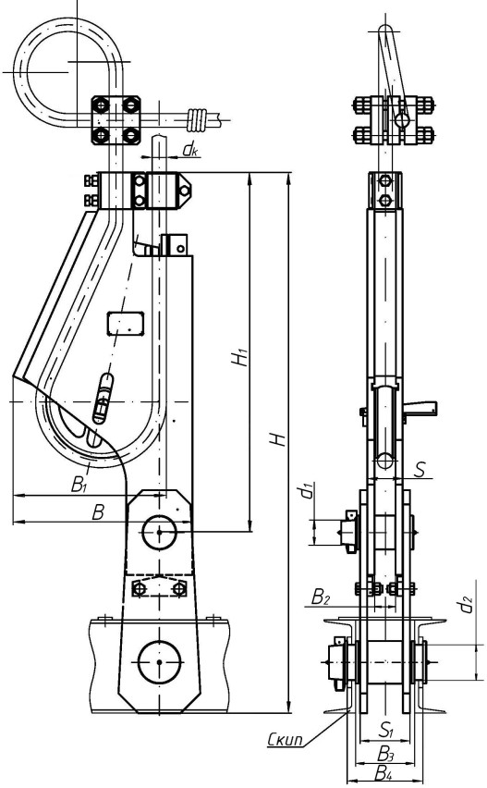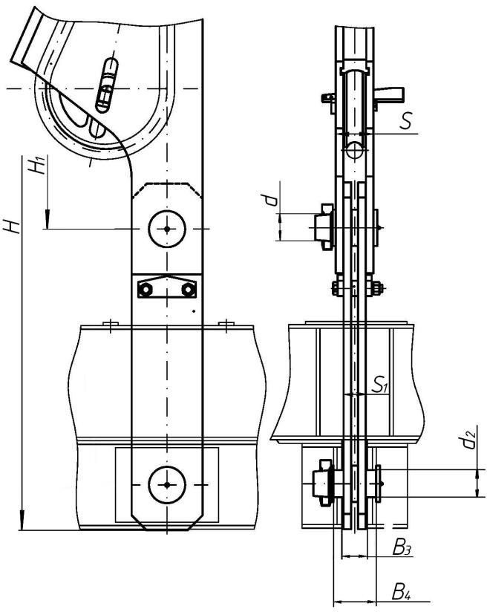Suspension gear for skips UPS
Link (kinematic)

Its location is inside the thimble
Link
(kinematic)

Its location is outside the thimble
Inclusion of a roller in the delivery (indicating its length), checks, washers - as agreed with the Customer
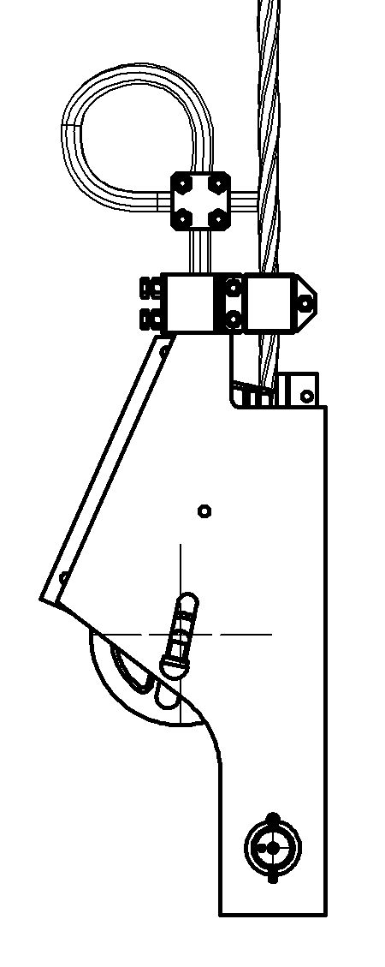
Fig. 3

Thimble KD
Thimble KD
Thimble KD

Fig. 1
Fig. 2

Tel.: +38-066-379-04-61 5
E-mail: petrov.evgeniy@corum.com

